############# INSTRUCTIONS TO SETUP PYTHON ###################

1>Downloaded Python 3.7.0 from <https://www.python.org/downloads/>

2>Downloaded IDE for Python called professional PyCharm

<https://www.jetbrains.com/pycharm/download/download-thanks.html?platform=windows>

3>Add python and pip to environment variable

C:\Users\rashroff\AppData\Local\Programs\Python\Python37-32

C:\Users\rashroff\AppData\Local\Programs\Python\Python37-32\Scripts

4>pip install virtualenvwrapper

############# INSTRUCTIONS TO SETUP PYTHON ORACLE CONNECTION ###################

Pre Installed Software : Anaconda

(<https://www.anaconda.com/download/>)

STEP 1. Open “Anaconda Prompt” by searching in Start Menu

STEP 2. Use command “pip install cx_Oracle”. After installation, you can close Anaconda Prompt

STEP 3. Install “Visual Studio 2017 x64” ([vc_redist.x64.exe](https://aka.ms/vs/15/release/vc_redist.x64.exe)) from the link -https://support.microsoft.com/en-us/help/2977003/the-latest-supported-visual-c-downloads#bookmark-vs2013

STEP 4. Download Oracle Instant Client version 18.3.0.0.0 Basic Light Package from the link - <https://www.oracle.com/technetwork/topics/winx64soft-089540.html>

STEP 5. Unzip the zip file downloaded in STEP4 in C:/oracle

STEP 6. Search in start menu “edit the system environment variables” and open it. The below screen will appear.

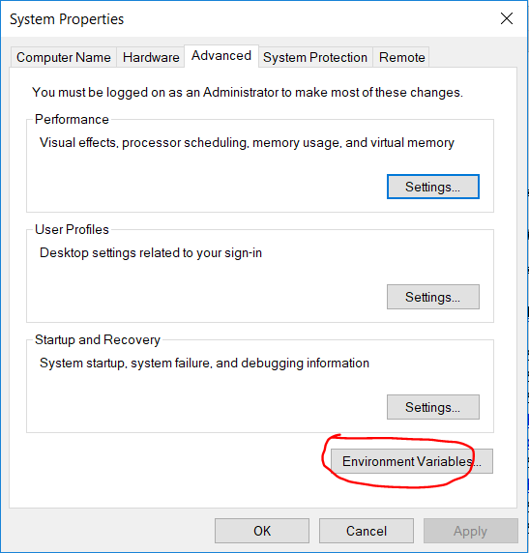

STEP 7. Click on Environment Variables.

STEP 8. Double click on Path in System variables as shown below –

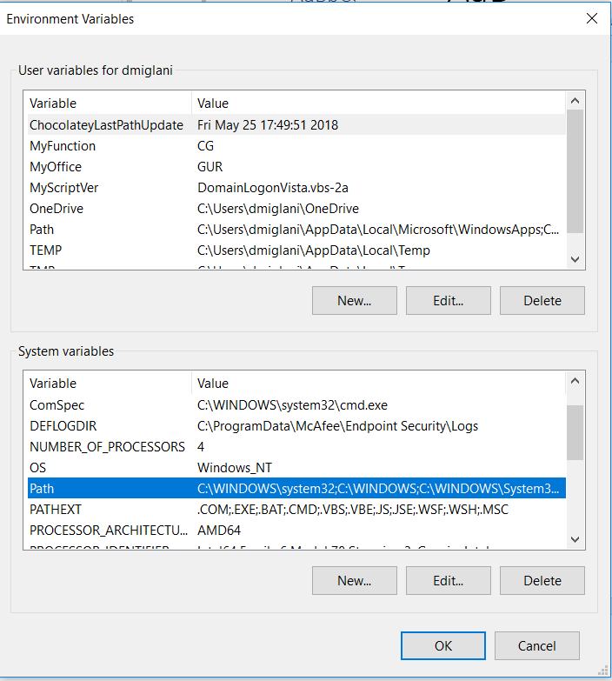

The below screen will appear –

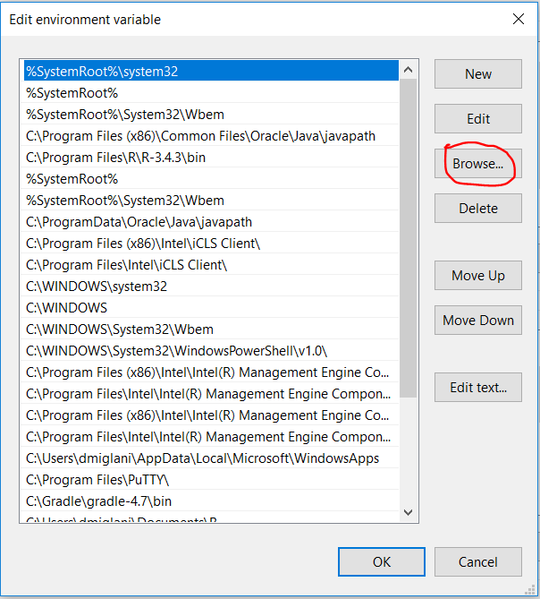

STEP 9. Use the Browse Tab to select where we unzipped our folder in STEP 5 i.e. “C:\oracle\instantclient_18_3”

STEP 10. Click OK

STEP 11. Restart the PC